Multiple-choice section – choose the correct answer

Question 1 [9.1]

Which of the following does *not* represent a quadratic expression?

**A** *y*2 + 6*y* – 4 **B** -2*h*2 – *h* + 6 **C** 9*v*3 + 15 – 2 **D** 16 + *r*2 + 2

Question 2 [9.3]

To obtain the graph of *y* = (*x +* 4)2 – 1 you translate the graph *y* = *x*2:

**A** 4 units to the right and 1 unit down

**B** 4 units to the left and 1 unit down

**C** 4 units to the right and 1 unit up

**D** 4 units to the left and 1 unit up

Question 3 [9.3]

The dilation factor for *y* = -2*x*2 + 4 is:

**A** -2 **B** 2 **C** 4 **D** -

Question 4 [9.4]

Which of the following equations would graph as a circle?

**A** *x*2 + *y*2 = 16 **B** *x*2 + *y* = 25 **C** *x* + *y*2 = 36 **D** *xy* = 9



Question 5 [9.2]

The solution of *x*2 + 5*x* – 24 = 0 is:

**A** *x* = -24 **B** *x* = 8, -3 **C** *x* = -8, -3 **D** *x* = -8, 3

Question 6 [9.6]

Consider the table of values below. If *y* is directly proportional to *x*, the equation for the relationship between *x* and *y* is:

|  |  |  |  |  |
| --- | --- | --- | --- | --- |
| *x* | 0 | 1 | 2 | 3 |
| *y* | 0 | 7 | 14 | 21 |

**A** *y* = *x*  **B** *y* = 7*x* **C** *y* = 3*x*  **D** *yx*2 = 7

Question 7 [9.4]

What is the centre and radius of the circle with the equation (*x –* 1)2 + (*y* + 2)2 = 144?

**A** (1, -2),144 **B** (-1, 2),12 **C** (1, -2),12 **D** (-1, 2),144

Question 8 [9.3]

The turning point of *y* = (*x* + 5)(*x* – 7) is:

**A** (5, -7) **B** (1, -36) **C** (0, -35) **D** (1, -42)

Question 9 [9.5]

Determine the equation of a rectangular hyperbola where *a* = 1, and with asymptotes at *x* = -4 and *y* = 3.

**A** *y* = + 4 **B** *y* = + 3 **C** *y* = – 3 **D** *y* = + 3

Question 10 [9.7]

If *p* is inversely proportional to *q* and the constant of proportionality is 45,the equation that represents this relationship is:

**A** *p* = 45*q*  **B** *pq* **C** *p* =  **D** *p* = 

Multiple-choice results: ___ / 10

Short answer section

Question 11 4 marks [9.1]

For the following graph with the following equation *y* = -*x*2 – 3*x* – 4, state:

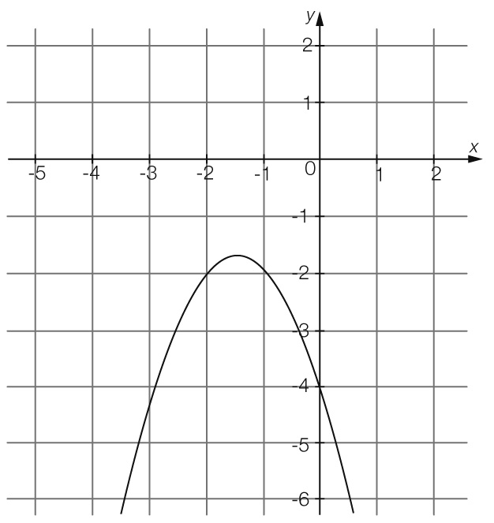

**(a)** the coordinates of the turning point ___________________________

**(b)** the *x*-intercepts ___________________________________________

**(c)** the *y*-intercept ___________________________________________

**(d)** the equation of the axis of symmetry _________________________

Question 12 9 marks [9.1]

For the following equation *y* = 2*x*2 – 5*x* – 7:

**(a)** Complete a table of values for -2 ≤ *x* ≤ 5

|  |  |  |  |  |  |  |  |  |
| --- | --- | --- | --- | --- | --- | --- | --- | --- |
|  |  |  |  |  |  |  |  |  |
|  |  |  |  |  |  |  |  |  |

**(b)** Plot the points on a Cartesian plane and join with a smooth curve.

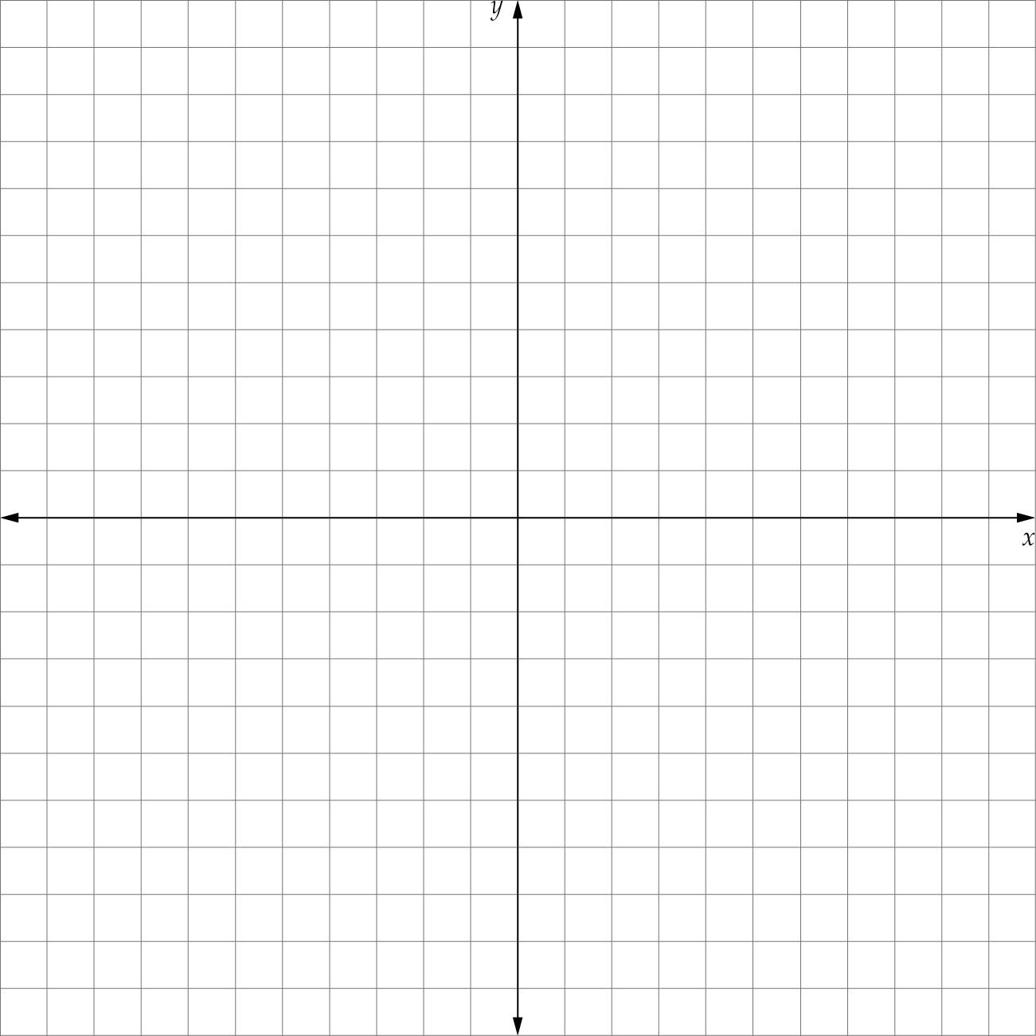

|  |
| --- |
| **(c)** Determine the coordinates of the turning point and label it on your graph.  **(d)** What is the nature of the turning point of your graph?  **(e)** What is the value of *y* where *x* = 8? |

Question 13 6 marks [9.2]

Solve the following equations using the null factor law.

**(a)** *x*2 – 11*x* + 24 = 0 **(b)** *x*2 + 3*x* = 28

**(c)** 2*x*2 – 12 = 0

Question 14 2 marks [9.2]

Determine the *x*-intercepts for the graph of the equation *y* = 2*x*2 + 6*x* + 4.

Question 15 6 marks [9.3]

State the transformations that should be made to the graph of *y* = *x*2 to obtain the graph of each of the following.

|  |  |  |  |  |  |
| --- | --- | --- | --- | --- | --- |
|  | **Equation** | **Dilation**  **factor** | **Reflection in *x*-axis?** | **Horizontal translation** | **Vertical**  **translation** |
| **(a)** | *y* =  *x*2 + 1 |  |  |  |  |
| **(b)** | *y* = 4(*x* – 4)2 – 1 |  |  |  |  |
| **(c)** | *y* = -3(*x* + 2)2 – 1 |  |  |  |  |

Question 16 6 marks [9.4]

Consider the following graph:

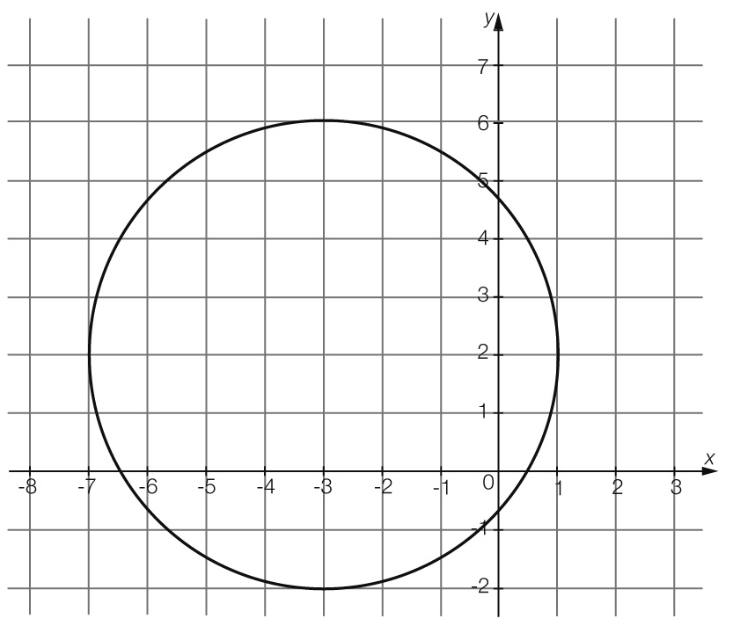

**(a)** Determine the centre and radius of the circle algebraically.

**(b)** Use your answers in **(a)** to determine the equation of the circle.

Question 17 2 marks [9.4]

A circle has the equation (*x* + 5)2 + (*y* + 3)2 = 36.

**(a)** What would the equation of this circle be if it is translated 6 units right and 4 units up and the radius is increased by 1 unit?

**(b)** After the above transformation has been made, the circle is then reflected in the *x*-axis. What is the equation of the transformed circle?

Question 18 4 marks [9.5]

Consider the following graph:

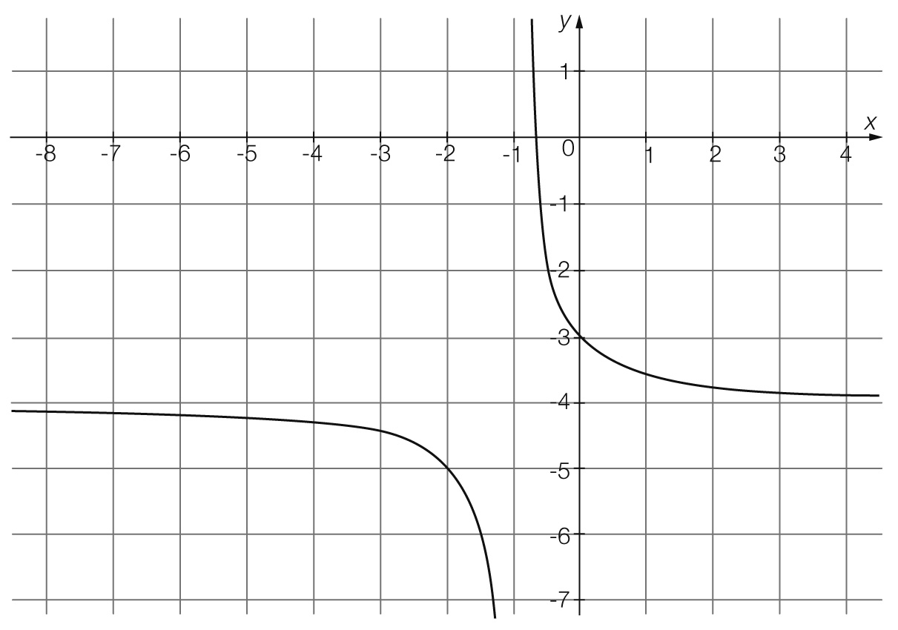

**(a)** What is the name of the relationship shown by this graph?

**(b)** What is the equation of the horizontal asymptote?

**(c)** What is the equation of the vertical asymptote?

**(d)** Determine the equation of the graph.

Question 19 4 marks [9.6]

The power (*P*) required to propel a ship varies directly as the cube of the speed (*s*) of the ship.

**(a)** Write an equation to represent this information.

**(b)** If 3.8 MW (megawatts) will propel the ship at 19.3 km/h, use this information to find the value of the constant of proportionality.

**(c)** What power will propel the ship at a speed of 24.2 km/h?

**(d)** What is the speed of the ship if 2.45 MW will propel the ship?

Question 20 4 marks [9.7]

Consider the table of values:

|  |  |  |  |  |
| --- | --- | --- | --- | --- |
| *x* | 2 | 4 | 6 | 8 |
| *y* | 36 | 18 | 12 | 9 |

**(a)** Describe the relationship between the two quantities *x* and *y*.

**(b)** Determine the value of the constant of proportionality for this relationship.

**(c)** Write the equation for this relationship.

**(d)** What is the value of *y* when *x* = 24?

Short answer results: ___ / 44

Extended answer section

Question 21 9 marks [9.1]

A ball that is thrown follows a parabolic path where its height above the ground (*h* in metres) at any time (*t* in seconds) is given by the relationship *h* = -5*t*2 + 15*t*.

**(a)** Complete a table of values and use it to plot the graph of this relationship, showing all key   
 features.

|  |  |  |  |  |
| --- | --- | --- | --- | --- |
|  |  |  |  |  |
|  |  |  |  |  |

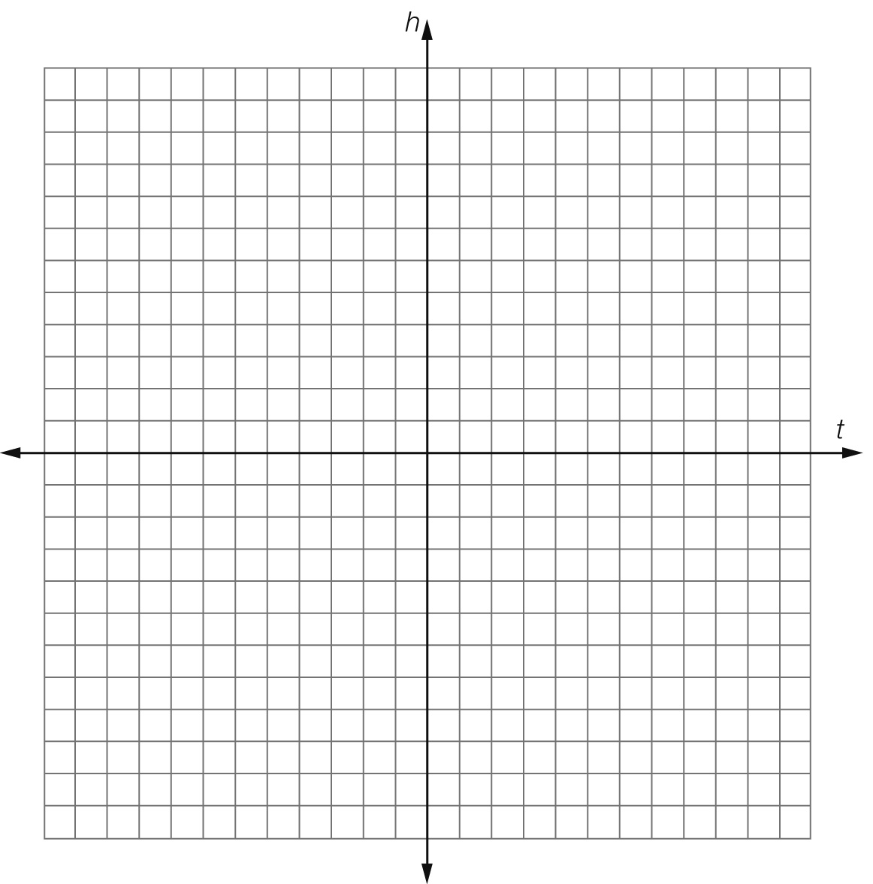

**(b)** What is the maximum height of the ball?

**(c)** At what time does the ball reach its maximum height?

**(d)** When does the ball hit the ground?

Question 22 4 marks [9.4]

A circle has a radius of 3 and its centre at (4, 0).

**(a)** What is the equation of the circle?

**(b)** Graph the circle on the axes below.

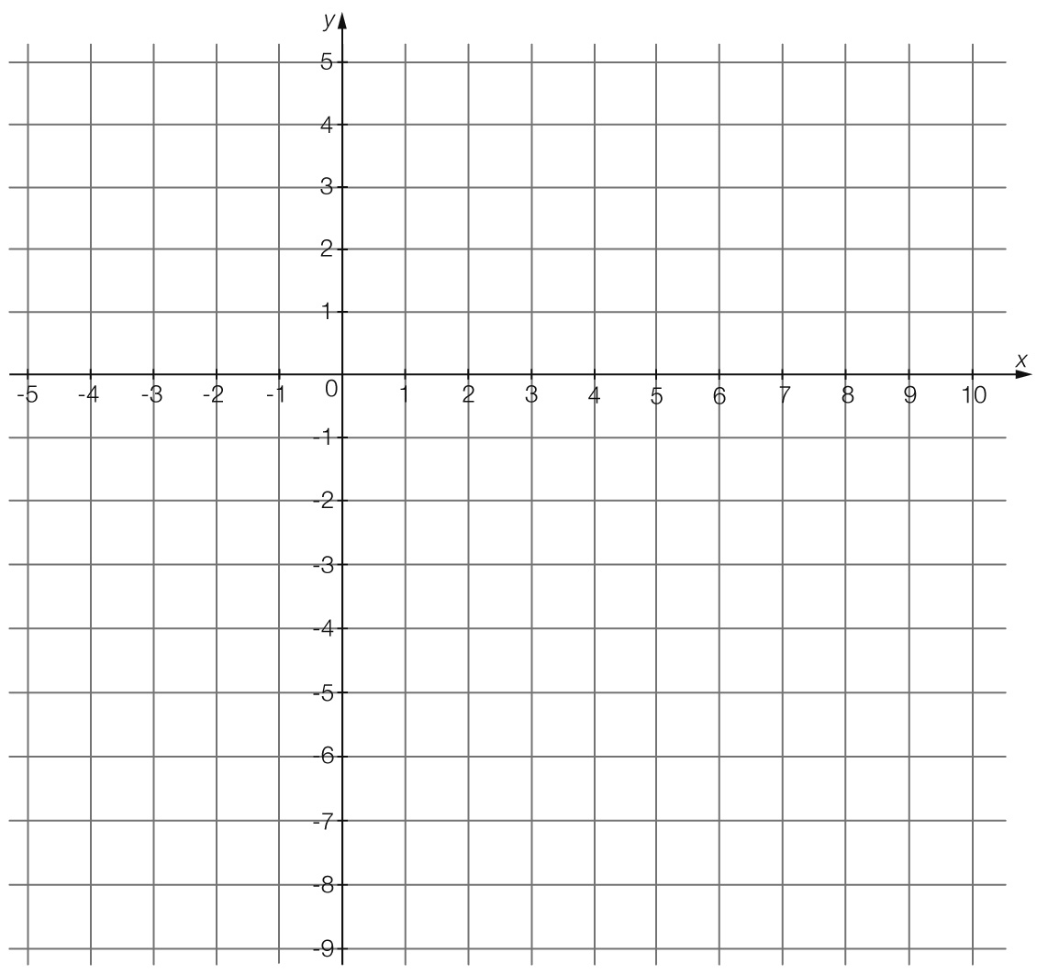

Question 23 5 marks [9.7]

The pressure of an amount of gas inside a scuba diving tank depends on the volume of the tank. For example, the pressure of the air inside a tank with a volume of 10 L is 500 kPa.

**(a)** Find the constant of proportionality to complete the table below.

|  |  |  |  |  |
| --- | --- | --- | --- | --- |
| Volume (*V*) | 2 | 4 | 8 | 10 |
| Pressure (*P*) |  |  | 625 | 500 |

**(b)** Plot the graph of volume against pressure.



**(c)** Is the relationship an example of direct or inverse proportion? Explain your answer.

**(d)** When the pressure is 1800 kPa, what is the volume?

Question 24 7 marks [9.5]

For the following equation y = 2(x – 4) + 1.

**(a)** Complete a table of values for 0 ≤ x ≤ 7

|  |  |  |  |  |  |  |  |
| --- | --- | --- | --- | --- | --- | --- | --- |
|  |  |  |  |  |  |  |  |
|  |  |  |  |  |  |  |  |

**(b)** Plot the points on a Cartesian plane and join with a smooth curve.

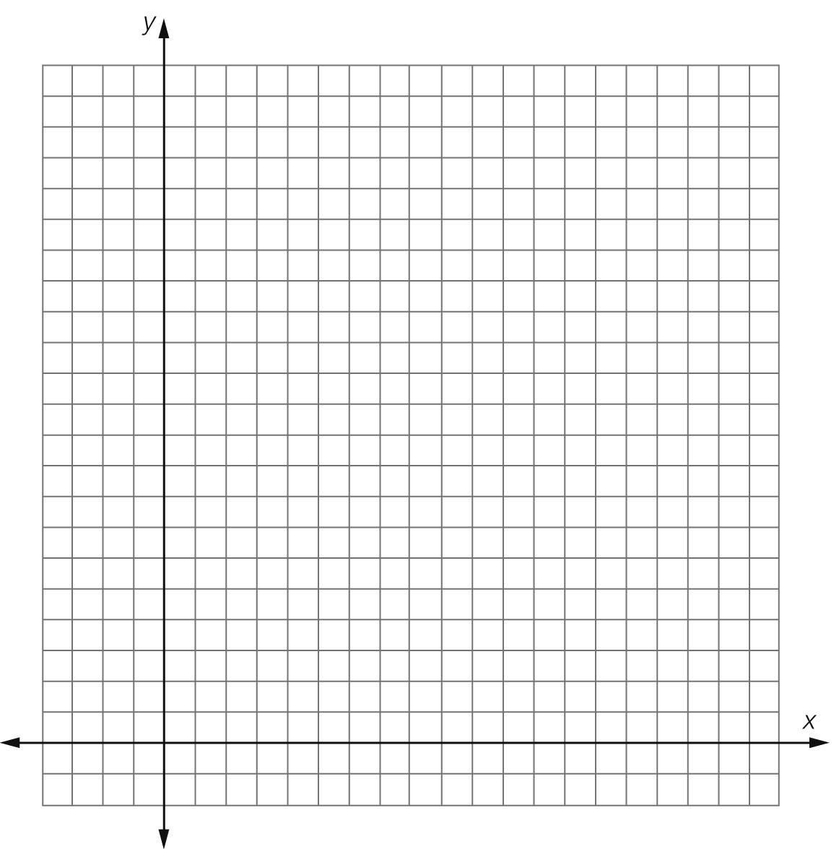

**(c)** What is the name of graph of this relationship?

**(d)** What is the equation of the asymptote?

**(e)** What is the value of *y* where *x* = 12?

Extended answer results: ___ / 25

TOTAL test results: ___ / 79